12/06/12

Name-Sagar Desai

Partners- Doumbia

Pan

**Physical Pendulum**

**Objective-** To measure the period of a physical pendulum at a different point of suspension and measure its theoretical as well as experimental values.

**Procedure-** A rod of .55m was suspended on a hanger. The end of the rod was placed between the photo gates. The 11th hole was at the center so the center of mass of the rod was at that hole. The rod was applied with a minimum force so that the angle that its makes is very small. The photo gate calculated the period for 10 intervals. . The rod was pivoted at hole 1st , 3rd, 5th ,7th and 9th respectively. The period recorded by the photo gate is the measures period. The measured period is compared to its theoretical period at the pivoted hole.

**Theoretical Value**

Center of mass is at **11th** hole.

Length of the rod (L)=.55m

Distance between the holes =.025 m

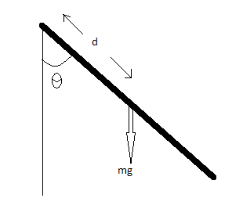Theoretical Value=

|  |  |  |  |  |
| --- | --- | --- | --- | --- |
| Pivot at the hole # | d (distance between the 11th hole and the pivoted hole in m) | T(measured) (sec) | T(theoretical) (sec) | %difference |
| 1 | .25 | 1.1814 | 1.1888 | .62 % |
| 3 | .2 | 1.1369 | 1.1460 | .79 % |
| 5 | .15 | 1.1204 | 1.1319 | 1.01 % |
| 7 | .1 | 1.1628 | 1.1909 | 2.35 % |
| 9 | .05 | 1.4123 | 1.4941 | 5.47 % |

**The dependence of distance and the period-**

The period of the pendulum (**T**) varies with distance (**d**), where d is the distance from the center of mass. When the object at the center of mass, we get no oscillations. This phenomenon is observed in the graph. The line goes to infinity when the **d** is zero. As the d increases the curve decreases. We see that the Period (**T**) is inversely proportional to **d**. It is because the value of **d** is too small to influence the period. But after certain point the line starts to increase and now the period is directly proportional to **d**. It is because the value of d is large to influence the value of **T**.